FINANCIAL TRANSACTIONS & LOANS DASHBOARD

MONISRI L
E25FA028
B.COM FINTECH AND AI

1. Introduction
In this project, I developed a Financial Transactions and Loans Dashboard using Microsoft Power BI. The project is based on banking data consisting of 11 different tables. These tables provide details about customers, accounts, loans, transactions, branches and other banking information.
The main aim of this project is to present banking information through charts and visual reports instead of analysing raw data manually. The dashboard helps to understand customer details, account balances, loan information and transaction activities.
I used KPI cards, different charts, tables and slicers to display the important financial information. I also included drill-down, tooltips and conditional formatting to make the dashboard more useful.
This project helped me understand how Power BI can be applied to banking data and how visual reports can make financial information easier to analyse.
2. Objectives
The main purposes of this project are:
- To study customer, account, loan and transaction details.
- To calculate important banking indicators using DAX.
- To identify the number of customers and active accounts.
- To compare accounts based on their types.
- To examine loans according to their status.
- To study monthly transaction performance.
- To compare different types of transactions.
- To create an interactive financial dashboard.
- To use drill-down and tooltips for additional details.
- To apply conditional formatting for better data presentation.

3. Dataset Description
For this project, I worked with a banking dataset containing 11 tables. Each table provides different information required for financial analysis.
The tables used are:
- Customers
- Customer Types
- Accounts
- Account Types
- Account Statuses
- Loans
- Loan Statuses
- Transactions
- Transaction Types
- Branches
- Addresses
These tables contain details such as customer information, account balances, loan principal amounts, interest rates and transaction values.
By connecting these tables, I was able to analyse different banking activities in a single Power BI report.
4. Data Cleaning and Preparation
Before designing the dashboard, I used Power Query Editor to make the dataset ready for analysis.
The following changes were performed:
- Removed repeated values from Account ID, Customer ID, Address ID and Loan ID.
- Changed date-related columns into the correct Date format.
- Converted Balance, Principal Amount and Amount into Fixed Decimal Number.
- Replaced missing customer names and address details with "Unknown".
- Corrected the date of birth format using the English (India) locale.
- Changed date conversion errors into null values.
- Used Trim and Clean options to remove unnecessary spaces and unwanted characters from transaction descriptions.
These operations helped improve the quality of the data and made it suitable for calculations and visualisation.
5. Relationships Between Tables
I connected the different tables in Power BI Model View by creating 7 relationships.
These connections help combine information from different tables. For example, customer details can be connected with account information, while transaction details can be linked with transaction types and branches.
I also kept some relationships inactive because they were not required for every calculation.
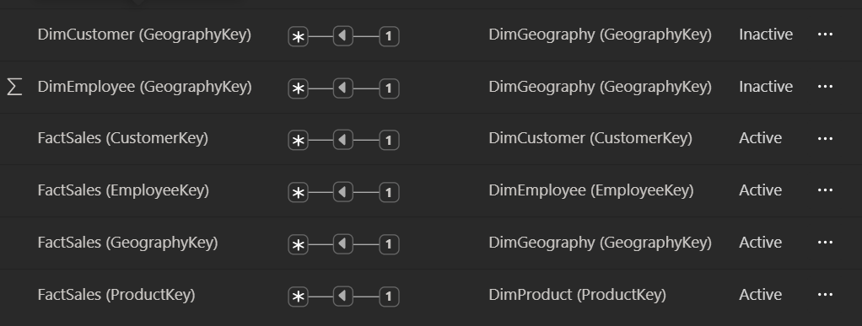
The inactive relationships included:
- DimCustomer (Geographykey)
- DimEmployee(Geographykey)
I used the USERELATIONSHIP() function in selected DAX calculations to use these inactive connections whenever required.
This data modelling process helped the different tables work together for the dashboard analysis.
6. DAX Measures
I created DAX measures to calculate the important financial information required for the dashboard.
The measures used include:
DAX Measure | Purpose
Total Customers | Counts the unique customers.
Total Accounts | Finds the number of unique accounts.
Total Account Balance | Adds the balances of all accounts.
Active Accounts | Counts accounts having Active status.
Total Loans | Counts the unique loan records.
Total Loan Principal | Calculates the combined loan principal amount.
Average Interest Rate | Finds the average interest rate.
Active Loans | Counts loans with Active status.
Total Transactions | Counts the unique transaction IDs.
Total Transaction Value | Adds the amounts of all transactions.
I also created additional measures such as Destination Transaction Value and Total Loan Amount using USERELATIONSHIP().
These calculations help analyse financial information and display the results in different dashboard visuals.
7. Visualisations Used
I selected different visualisations to present the banking information in a clear and organised manner.
7.1 KPI Cards
I designed four KPI cards to highlight the main financial details.
The cards display:
- Total Customers
- Active Accounts
- Active Loans
- Total Transaction Value
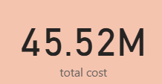 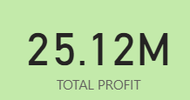
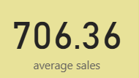 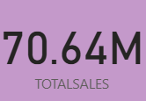
These cards give a quick summary of the banking information and help users understand the important figures at a glance.
7.2 Accounts by Account Type
I used a Clustered Column Chart to compare the number of accounts under different account categories.
- X-axis: Account Type
- Y-axis: Total Accounts
This chart helps users understand how accounts are distributed among different types.
7.3 Transactions by Month
I created a Line Chart to show transaction activity over different time periods.
- X-axis: Transaction Date
- Y-axis: Total Transactions
I used the date hierarchy to study transaction changes over time. This chart makes it easier to observe monthly transaction patterns.
7.4 Loans by Loan Status
I used a Donut Chart to display the number of loans under different status categories.
- Category: Loan Status
- Value: Total Loans
This visual helps users understand the distribution of loans and compare the different loan statuses.
7.5 Transactions by Type
I created a Clustered Bar Chart to compare transaction counts across different transaction types.
- Category: Transaction Type
- Value: Total Transactions
This chart helps identify the transaction categories with higher and lower activity.
7.6 Transaction Summary
I created a Table Visual to present transaction information in a detailed format.
The table contains:
- Transaction Type
- Total Transactions
- Total Transaction Value
This table helps users compare transaction categories based on both the number of transactions and their total monetary value.
8. Slicers and Interactive Features
I added three slicers to allow users to select the information they want to analyse.
The slicers used are:
1. Year
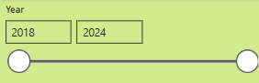
Allows users to view transaction information for a selected year.
2. Account Type
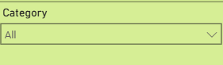
Helps filter the dashboard based on different account categories.
3. Transaction Type
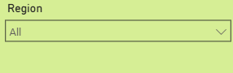
Allows users to view details related to a selected transaction category.
I also used the Edit Interactions option under the Format menu. It allows me to control how one visual affects another visual.
The available interaction settings are:
787ilter: Displays only the selected information.
- Highlight: Highlights the related values.
- None: Prevents one visual from affecting another.
These features make the dashboard flexible and easy to use.
9. Report-Page Tooltip
I created a separate report page named "Transaction Tooltip" to display extra transaction information.
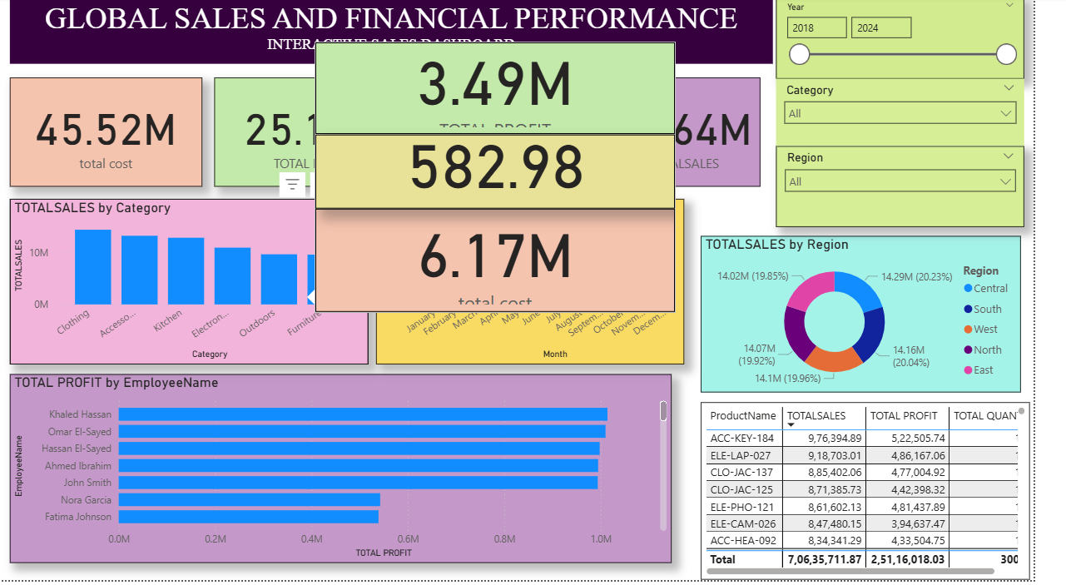
I enabled the Tooltip option in the Page Information settings.
I added three cards to this page:
- Transaction Type
- Total Transactions
- Total Transaction Value
After creating the tooltip page, I connected it to the Transactions by Type chart.
Now, when the user moves the cursor over a data point in the chart, additional transaction details can be viewed through the tooltip.
This feature provides more information without adding extra visuals to the main dashboard.
10. Conditional Formatting
I applied conditional formatting to the Total Transaction Value column in the Transaction Summary table.
I used Data Bars to represent the transaction values visually.
The formatting includes:
- Green bars for positive values.
- Red bars for negative values.
This makes it easier to identify and compare values in the table.
Conditional formatting improves the appearance of the report and helps users understand the differences between values quickly.
11. Key Findings
The dashboard helps analyse different areas of banking activities.
The main points that can be studied are:
- The overall number of customers and accounts.
- The number of accounts currently marked as active.
- The total number of active loans.
- The distribution of accounts across account types.
- The changes in transaction activity over time.
- The number of loans under different status categories.
- The transaction categories with higher or lower activity.
- The total transaction value for different transaction types.
- The financial information available through KPI cards.
- The importance of drill-down for examining yearly, quarterly and monthly transactions.
- The use of tooltips to display additional transaction details.
- The benefits of conditional formatting in comparing financial values.
The actual numerical results should be taken from the completed Power BI dashboard.

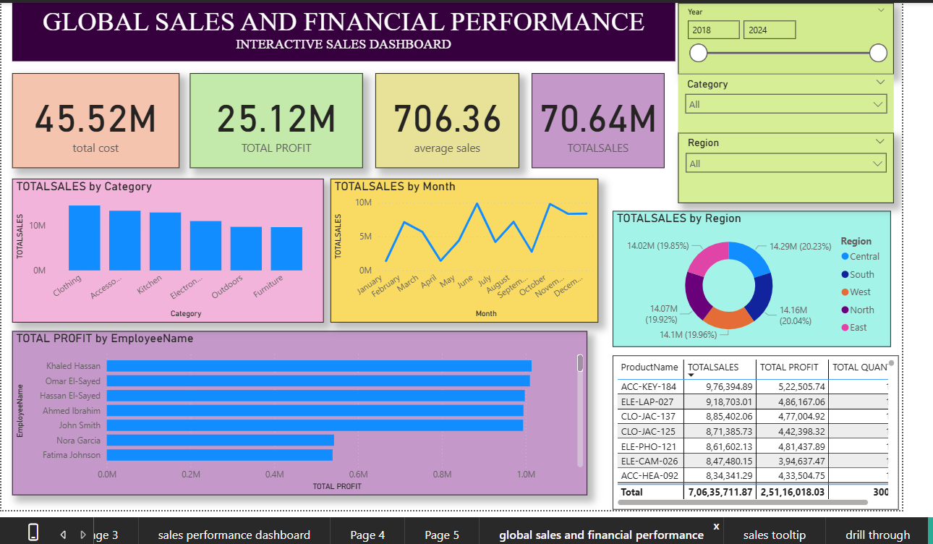
12. Conclusion
Through this Financial Transactions and Loans Dashboard project, I gained practical experience in working with banking data using Microsoft Power BI.
I learned how to prepare data using Power Query, connect multiple tables through relationships and create DAX measures for financial calculations.
I also developed different visualisations such as KPI cards, column charts, line charts, donut charts, bar charts and tables. The use of slicers, drill-down, report-page tooltips and conditional formatting helped me make the dashboard more interactive.
Overall, this project improved my knowledge of data modelling, financial calculations and data visualisation. It also helped me understand how Power BI can be used to study banking transactions, accounts and loans in a simple and effective way.

